Open-Ended Lab
Assignment of Open Ended Lab / CCA / PBL
Blooms Taxonomy | GAs | Knowledge Profile | EAs | WPs
P1 | GA-1 | WK1 WK2 WK3 WK4 WK5 WK6 WK7 WK8
P2 | GA-2 |  |  | WP1
P3 P4 P5 | GA-3  GA-4 GA-5 GA-6 GA-7  GA-18 |  | EA1 EA2 EA3 EA4 EA5 | WP2  WP3 WP4 WP5 WP6  WP7
 | GA-9
 | GA-10

OSPF Based Network Topology Project Report

Project Information
Student Name: Abdul Hannan
Registration Number: 021-24-69327
Course: Computer Networks
Instructor: Maam Armeesh
Class Slot: Monday (8:30 AM – 11:30 AM)

Motivation
The motivation behind this project is to gain practical understanding of dynamic routing in computer networks, specifically using OSPF (Open Shortest Path First). While routing protocols are often studied theoretically, implementing them in a simulated environment helps bridge the gap between theory and real-world networking.
Modern enterprise and campus networks consist of multiple routers and subnets that frequently change due to network growth or failures. Static routing becomes inefficient and error-prone in such scenarios. Therefore, this project was motivated by the need to understand how OSPF automatically discovers routes, selects the shortest path, and adapts to network changes without manual intervention.
Additionally, this project aims to:
- Develop hands-on skills in network topology design
- Understand IP addressing and subnetting for LANs and serial links
- Learn router configuration and troubleshooting using Cisco commands
- Simulate a realistic organizational network with multiple LANs
By implementing OSPF in this project, we demonstrate a routing method that is scalable, efficient, and widely used in professional networks, making this project both academically valuable and industry-relevant.

Concept (Problem Statement)
As networks grow in size, static routing becomes inefficient and difficult to manage. Multiple LANs connected through several routers require a routing method that can automatically select optimal paths and adapt to network changes.
The problem addressed in this project is to ensure reliable and dynamic communication between multiple LANs without manual route configuration. To solve this, the project implements OSPF (Open Shortest Path First), a dynamic link-state routing protocol that enables routers to automatically discover routes, calculate shortest paths, and maintain network connectivity efficiently.

1. Introduction
This project demonstrates the design and implementation of a multi-router computer network using OSPF (Open Shortest Path First) as the dynamic routing protocol. The network is designed and simulated using Cisco Packet Tracer, following real-world networking practices. The objective is to ensure full connectivity between multiple Local Area Networks (LANs) interconnected through Wide Area Network (WAN) serial links.

2. Project Objectives
- To design a scalable and realistic network topology
- To implement OSPFv2 for dynamic routing
- To configure serial point-to-point links using efficient IP addressing
- To verify connectivity between all end devices
- To understand OSPF neighbor formation and route exchange

3. Network Topology Overview
The topology consists of: - 7 Routers (Cisco 2621XM) - 7 Switches (Cisco 2950-24) - 14 PCs (End Devices)
Each router connects to: - One LAN via a switch - Two neighboring routers via Serial 0/0 and Serial 0/1 interfaces
The routers are connected in a ring topology, providing redundancy and multiple paths for data transmission.
Topology:
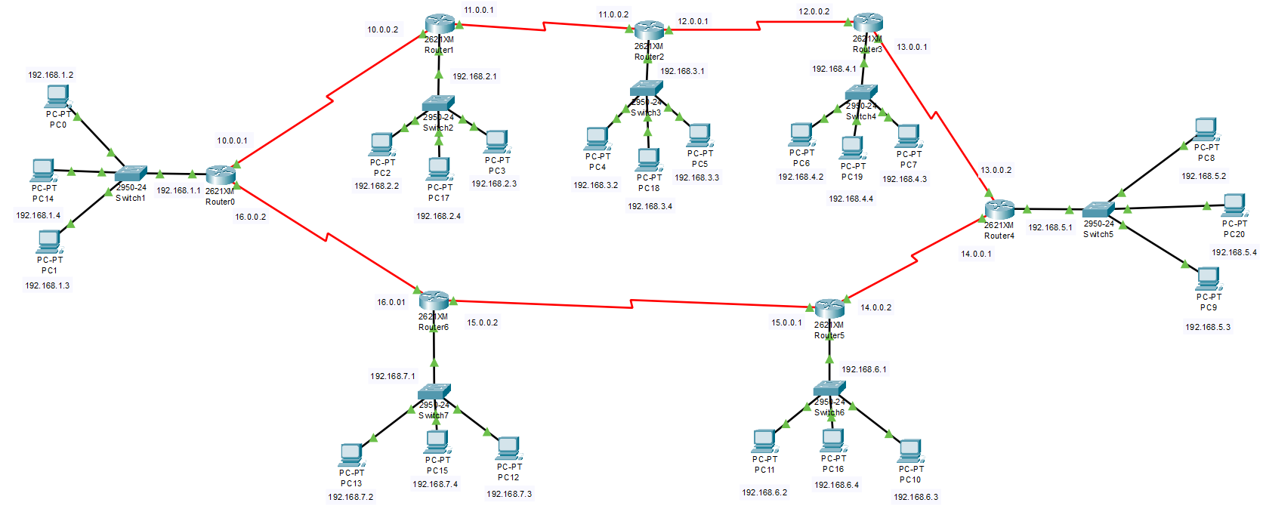

4. IP Addressing Scheme

4.1 LAN Networks
Each LAN uses a Class C private IP network:
Router | LAN Network | Default Gateway
Router7 | 192.168.1.0/24 | 192.168.1.1
Router10 | 192.168.2.0/24 | 192.168.2.1
Router11 | 192.168.3.0/24 | 192.168.3.1
Router12 | 192.168.4.0/24 | 192.168.4.1
Router13 | 192.168.5.0/24 | 192.168.5.1
Router9 | 192.168.6.0/24 | 192.168.6.1
Router8 | 192.168.7.0/24 | 192.168.7.1

4.2 WAN (Serial) Networks
All serial links use /30 subnet masks to minimize IP wastage.
Link | Network | IP Addresses
R7 – R10 | 10.0.0.0/30 | 10.0.0.1 – 10.0.0.2
R10 – R11 | 11.0.0.0/30 | 11.0.0.1 – 11.0.0.2
R11 – R12 | 12.0.0.0/30 | 12.0.0.1 – 12.0.0.2
R12 – R13 | 13.0.0.0/30 | 13.0.0.1 – 13.0.0.2
R13 – R9 | 14.0.0.0/30 | 14.0.0.1 – 14.0.0.2
R9 – R8 | 15.0.0.0/30 | 15.0.0.1 – 15.0.0.2
R8 – R7 | 16.0.0.0/30 | 16.0.0.1 – 16.0.0.2

5. Routing Protocol Used: OSPF

5.1 Why OSPF?
OSPF was selected because: - It is a link-state routing protocol - Provides fast convergence - Supports large and scalable networks - Uses cost metric based on bandwidth - Is widely used in enterprise networks

5.2 OSPF Configuration Details
- OSPF Version: OSPFv2
- Process ID: 1
- Area: 0 (Backbone Area)
Each router advertises: - Its connected LAN network - Its connected serial WAN networks

6. OSPF Implementation Summary
OSPF was configured on all routers using appropriate network statements. All routers successfully formed OSPF neighbor relationships and exchanged routing information dynamically.
➤ Pc Configuration
PC 0 (LAN 1):
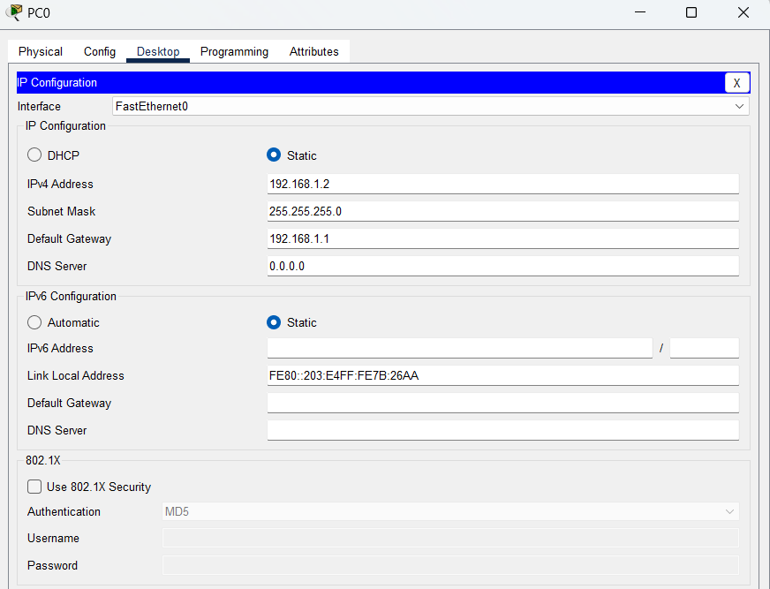

PC 2 (LAN 2):
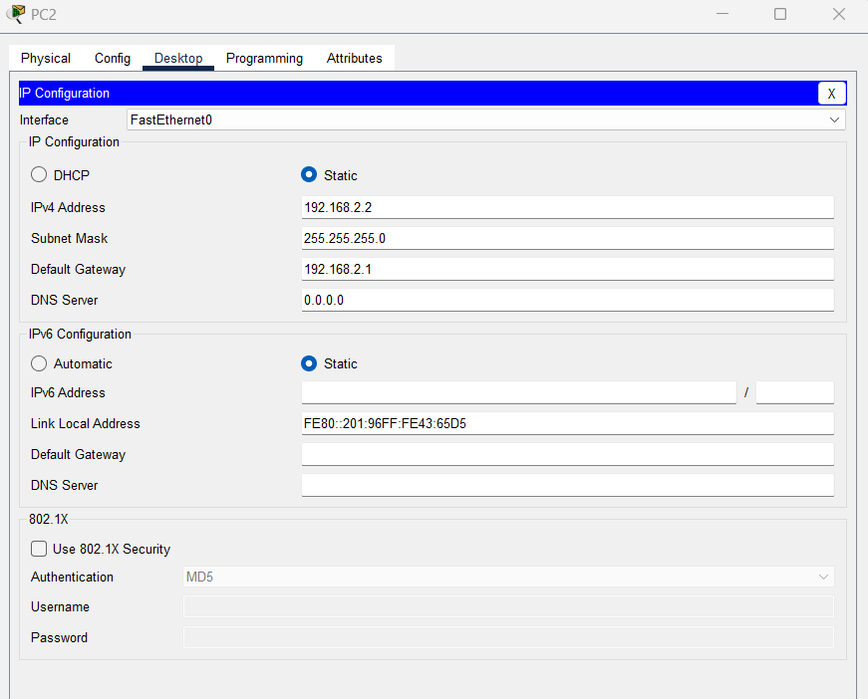

PC 4 (LAN 3):
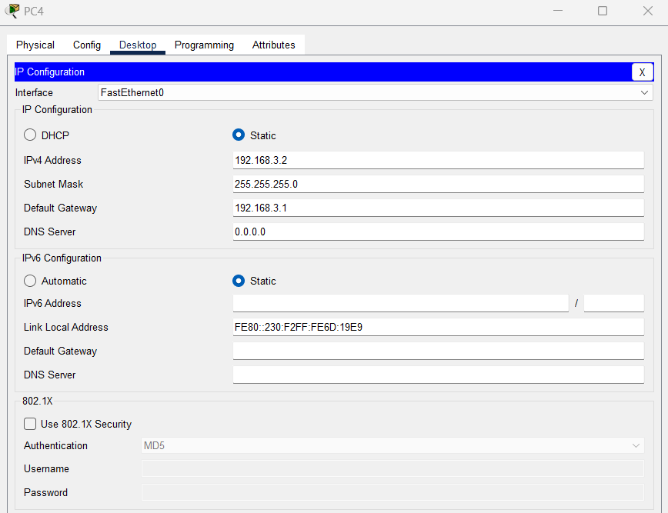

PC 6 (LAN 4):
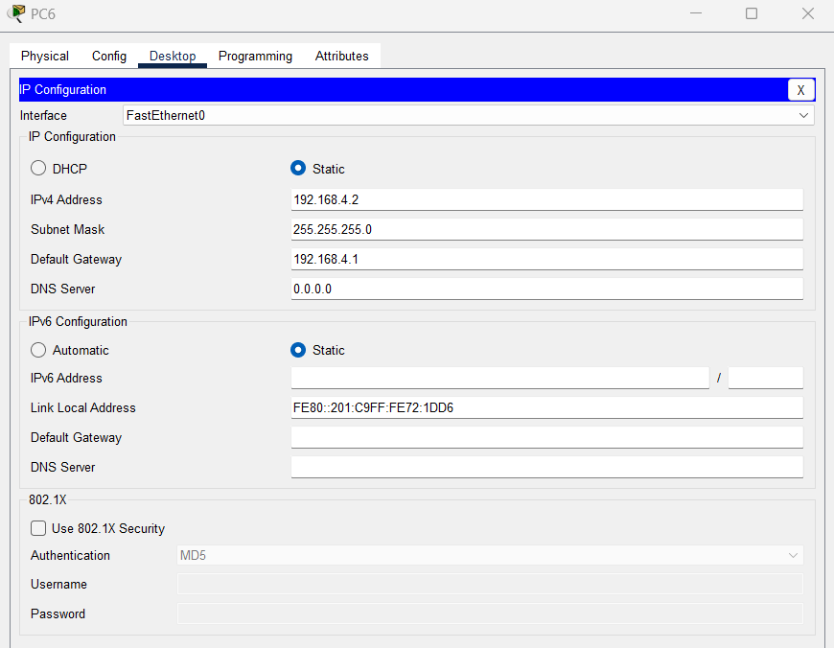
PC 8 (LAN 5):
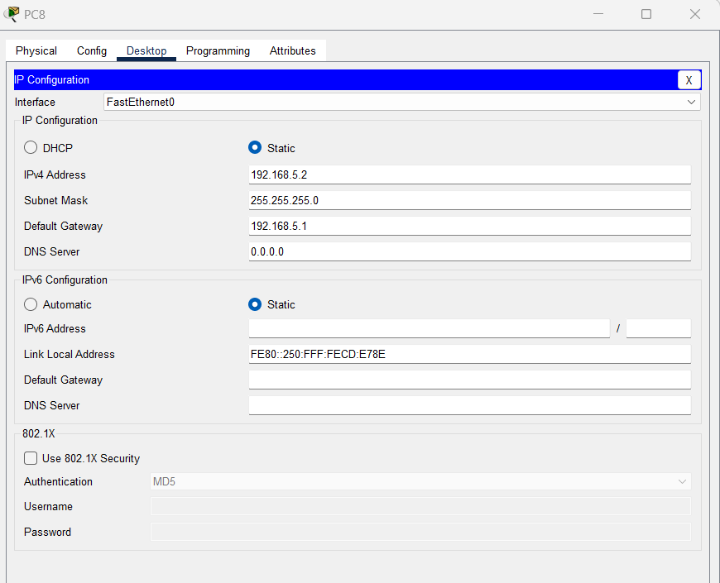

PC 10 (LAN 6):
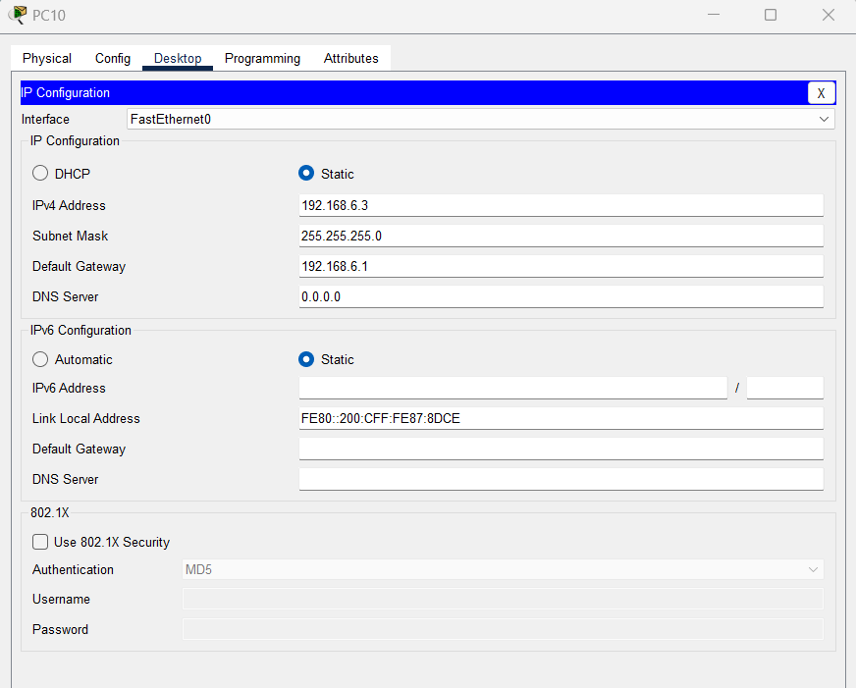
PC 13 (LAN 7):
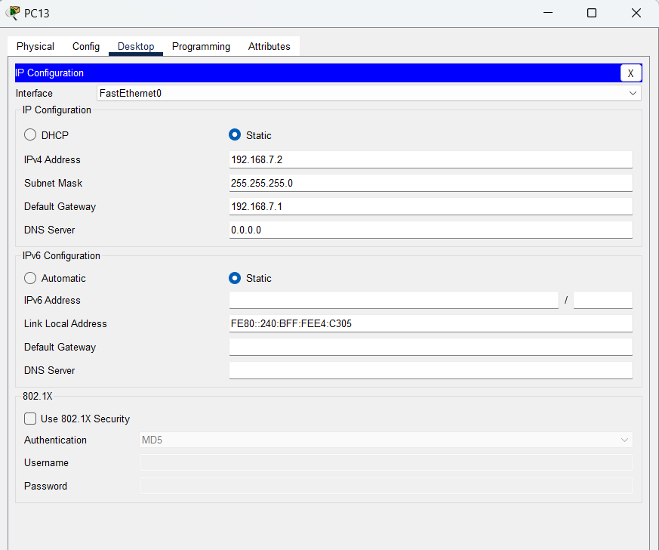

➤ Router Configuration
Router 0:
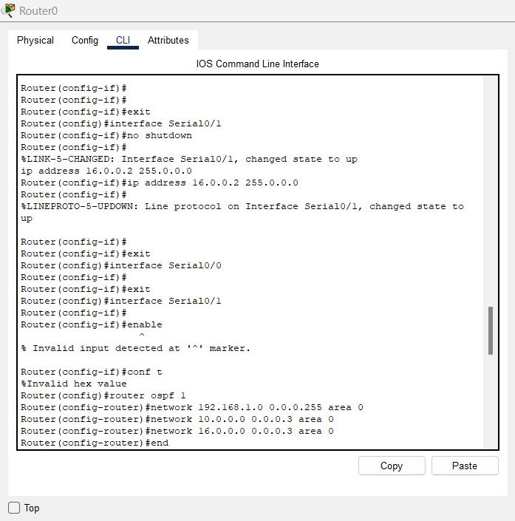
Router 1:
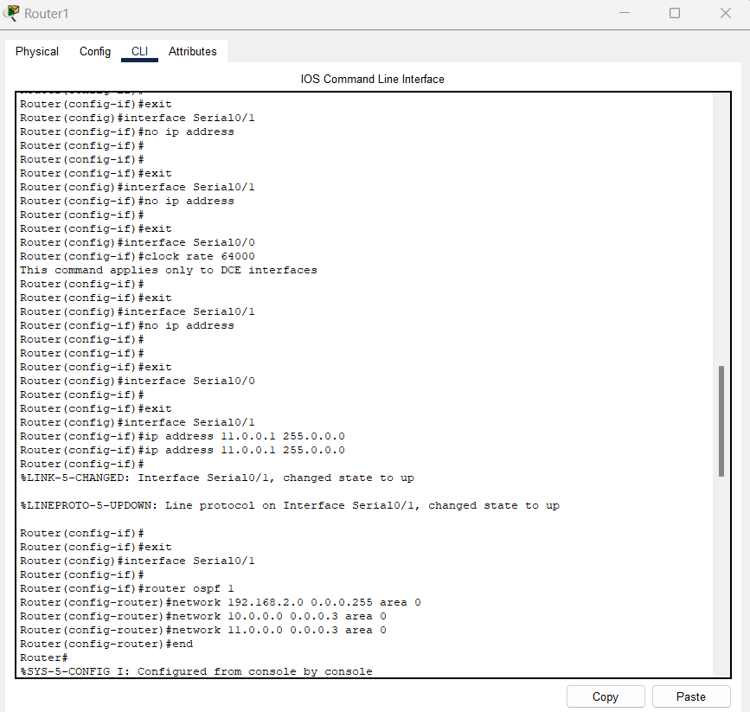
Router 2:
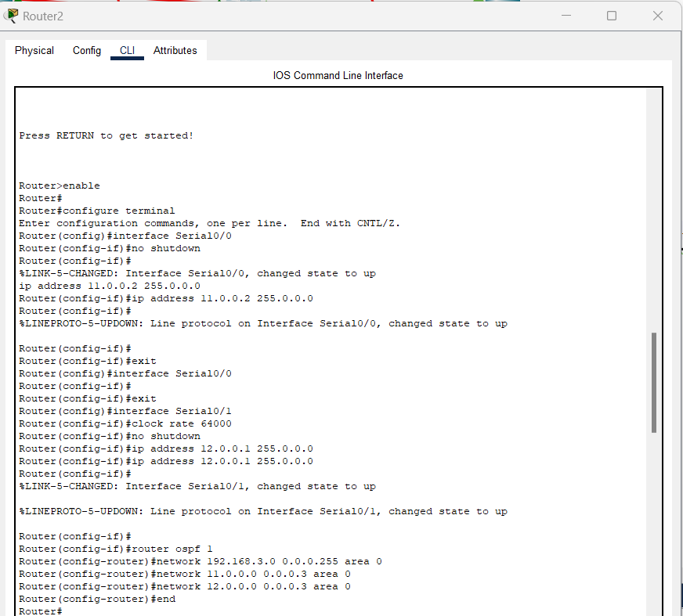
Router 3:
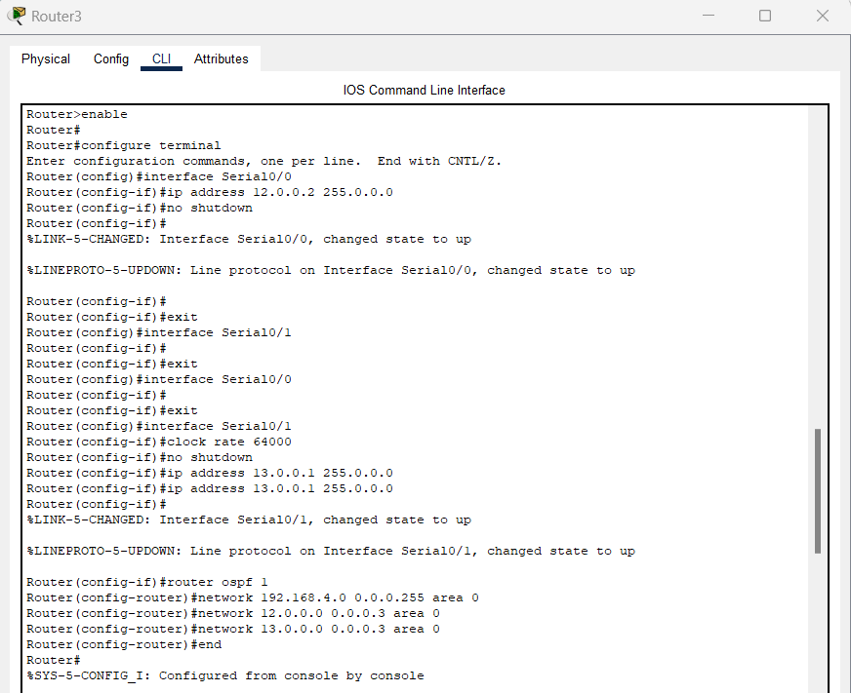
Router 4:
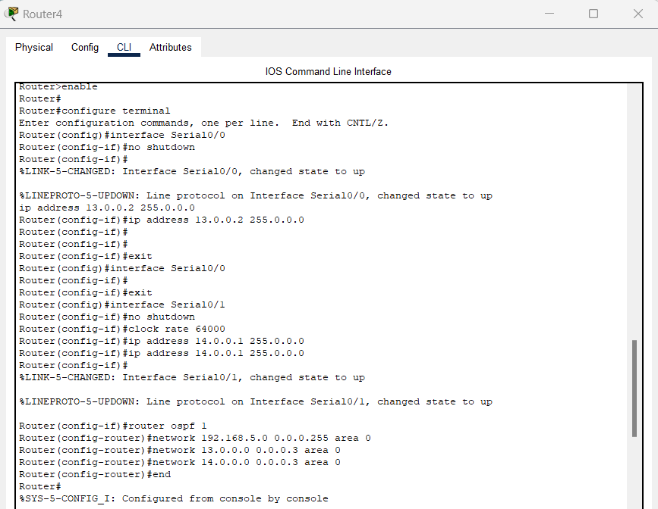
Router 5:
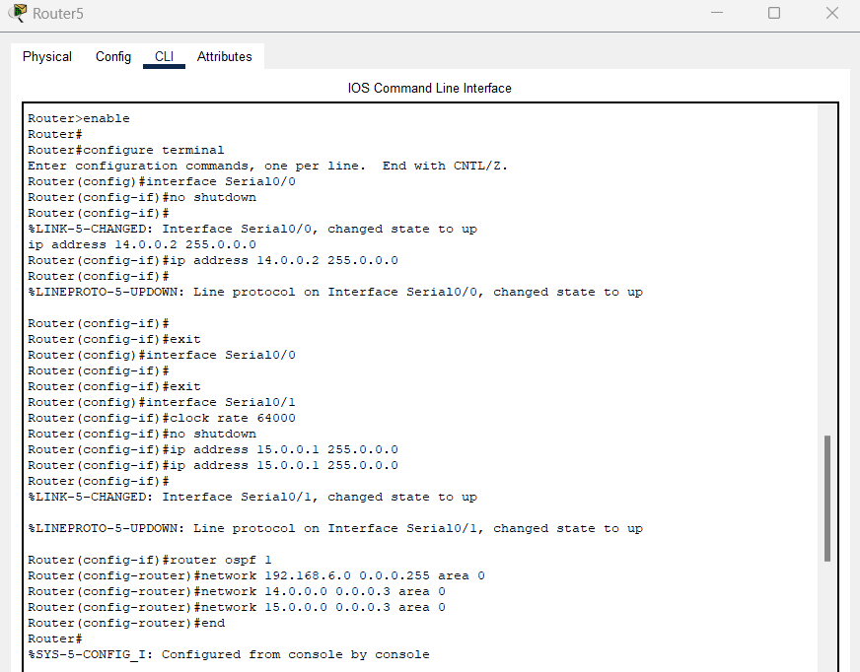
Router 6:
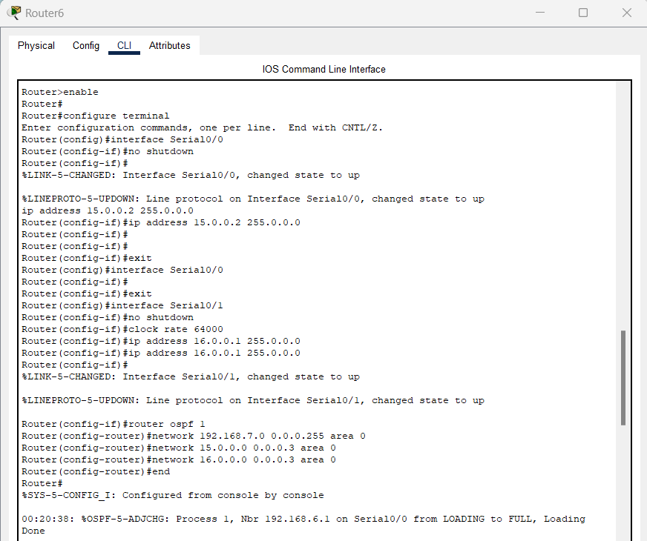

7. Testing and Results
Connectivity was tested using ping and traceroute commands between PCs located in different LANs.

Test Results:
- Successful ping between all PCs
- Correct routing paths observed using traceroute
- No packet loss detected

Testing:
PC 0 To PC 8:
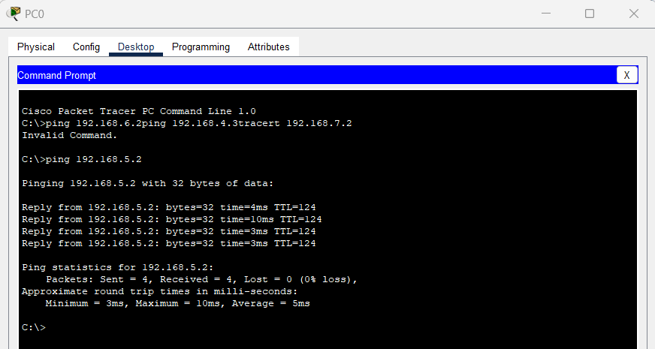
PC 6 To PC 13:
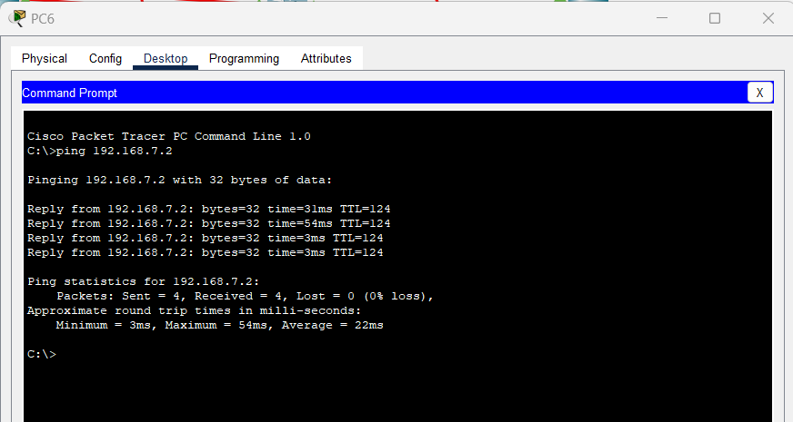

PC 5 To PC 1:
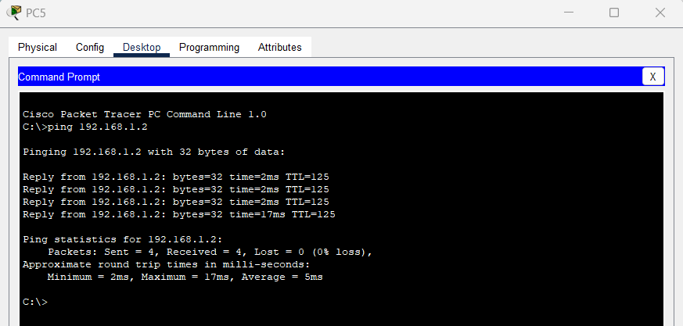
PC 10 To PC 2:
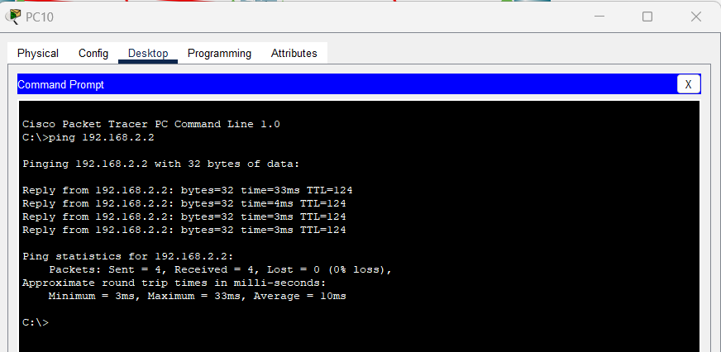

8. Conclusion
The project successfully demonstrates the implementation of a multi-router network using OSPF. Proper IP planning, efficient use of /30 subnets for WAN links, and correct OSPF configuration ensured dynamic routing and fault-tolerant communication. This project reflects real-world networking principles and fulfills all project requirements.

9. References
- Kurose, J. F., & Ross, K. W. Computer Networking: A Top-Down Approach. Pearson Education.
- Forouzan, B. A. Data Communications and Networking. McGraw-Hill.
- Cisco Networking Academy. Routing and Switching Essentials.
- RFC 2328 – OSPF Version 2, IETF.

